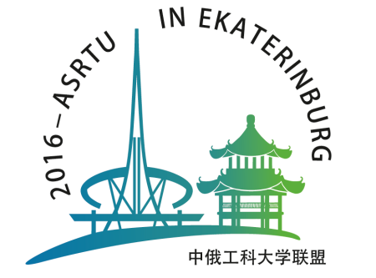
2016 ASRTU MEETING IN EKATERINBURG
23–26 June 2016
Ekaterinburg, Russia

Registration Form
Full name:
Organization:

Job Title:
Address:
Phone: Mobile:

E-mail: FAX:

Emergency Contact name and phone:

I plan to attend the following events (please mark)
□ IV Sino-Russian ASRTU Symposium on Advanced Materials and Processing Technology
□ Sino-Russian Ph.D. Students Innovation Forum
□ Regular Scheduled Meetings of ASRTU
Dates of stay in Ekaterinburg (please mark): □ 23 June □ 24 June □ 25 June □ 26 June

VISA REQUIREMENTS

If you need a visa to the Russian Federation, please enter the following info:
Full name (as it is written in your passport):
Nationality:
Place of birth (country/city):
Date of birth:
Gender: □ Male □ Female
Passport:
Period of stay in Russia: from to
Place of applying for a visa (country, city):
Permanent residence (address):

Please note: to enter the Russian Federation your passport must be valid at list 6 months after your planned date of departure from Russia.
Please send the filled registration form and the copy of your passport before 20th of March 2016
to organizing committee e-mail: boikova.anna@urfu.ru, ekaterinburg2016@163.com

